KCHC County Challenge Walk
Henry County Recreational Park
75 Park Rd New Castle

7th Annual County Challenge Walk

Saturday, September 15, 2018

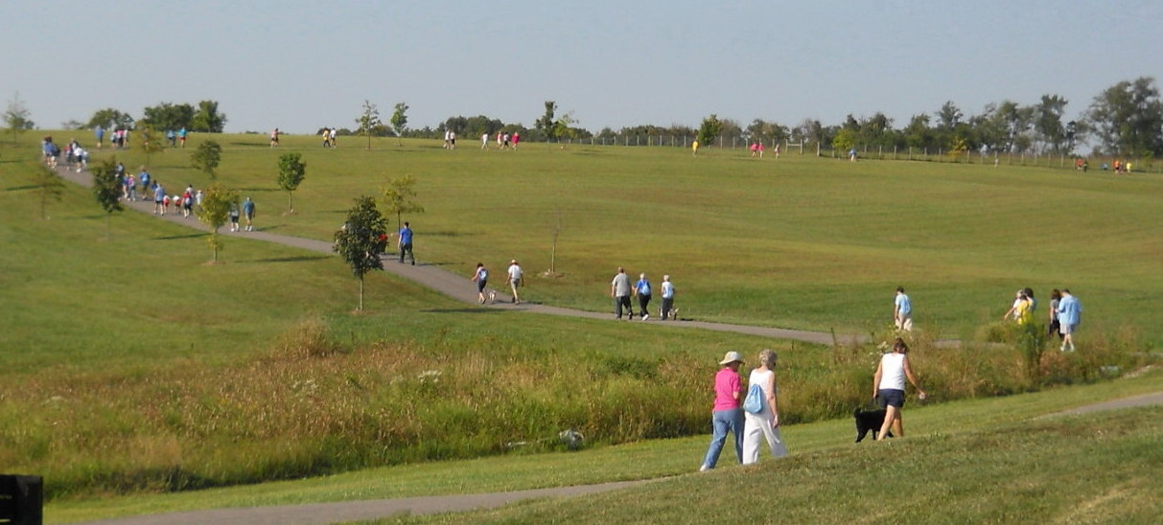
Registration 9:30 A.M. Walking 10-11 A.M. Celebration 11-11:30 AM

Can we bring the trophy back home?
How the walking challenge works!

-Walkers are given a
pedometer at registration or use own device to log steps while walking

-Steps are recorded and tallied once you are finished walking or at 11:00 A.M.

-Medals are awarded by age group for most steps walked and over-all winner at celebration

-Step totals then are compared to challenging counties

- The county with most steps wins the challenge and receives the “Traveling Trophy!”

Info: Mona Huff
845-6849
JOIN family and friends for a
GREAT Community Event ~
PROMOTE Community Health and Pride

Families walking with 2 or more
generations will have chance
to win tickets to:
Ken Kentucky Highland Renaissance Festival

Priamerica, Ron Laughlin

Port Royal United Methodist Church

